Kennedy Matchless G80 500.

What would you reckon a father wishes for his sons, when he gives each of them a Matchless to restore? When Greg Kennedy was 14, his father, Bill, presented each of his four sons a Matchless. The extended family, including uncle Bob, had been involved in speedway racing for years, building, tuning and racing solos and TQ (Three Quarter) cars. If lucky, the boys got the occasional passenger lap. In the workshop, the young Kennedy’s would ride the pedal lathe as counter weights, while Dad or Uncle Bob turned up some new part. When the Matchie restoring had finished, Greg took charge of a store of original parts. Heavily influenced by his motor sport childhood, Greg worked into a career as a Production Engineer and Industrial Designer. His love of racing simply continued unabated.

In 1958, Associated Motor Cycles (AMC - owners of AJS and Matchless) produced the 500cc Matchless G50, developed from the long standing 350cc AJS 7R. Both were pukka race bikes, designed for the Grands Prix. Presumably, the G50 was designed to take on Norton’s 500 Manx. While the 7R had a long and successful race history, timing proved the bigger bike’s downfall as it arrived not long before Honda et al arrived in Europe, changing the direction of machine development. Something less than 200 genuine Matchless G50s were constructed.

From 1961, Bob MacIntyre (Scotland) campaigned a privately developed frame using a variety of engines. The final development is now known as the ‘McIntyre Matchless’, using the G50 engine. McIntyre died as a result of a race crash, at Oulton Park, England, in 1962. Jack Findlay (Australia) took over the bike and the first replica frame was constructed. As income was tied to appearance money having two bikes, a 350 and a 500, was obvious. In 1968, Findlay was still racing the McIntyre and finished second, to Giacomo Agostini on the MV Augusta, in the 500cc World Championship.

The McIntyre frame is immediately distinguishable by the perimeter tubes running essentially horizontally, either side of the crankcase and gearbox rather than beneath, from the bottom of the twin down tubes to the swing arm pivot. The back bone of the frame is a pair of straight tubes from the top of the steering head to the swing arm pivot, similar in concept to current practice.

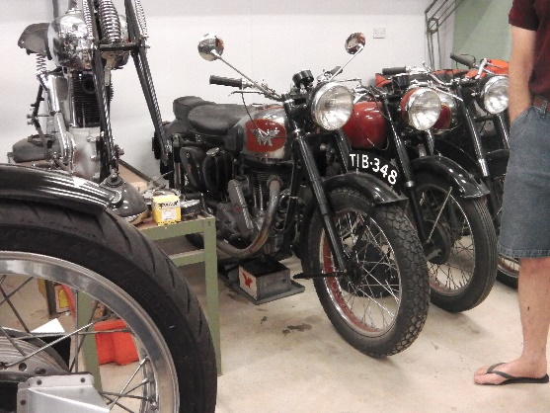
On the other hand, the Matchless G80 was a simple push rod, 500 single that had a 20 year run commencing in 1946. A bike for the masses of which plenty would have found their way to the race track, ridden by privateers and Clubmen, who simply couldn’t afford a Manx or G50. The G80 only revved to a claimed 5600rpm, with compression at no more than 7.3:1 (depending on model) and a 4 speed gearbox. Top speed was around 130km/h. It was a road bike. It was what Greg had restored.

In the mid 90’s, Greg decided that historic racing might provide the relief from work that most of us seem to need. Some reckon it’s a mid-life crisis. Maybe it’s just realising there are more interesting things in life. His first project was a replica 7R frame, from oval tube, for his G80 engine. At the time he announced the project a common response was “you’re mad son, you’ll never do that”.

When that bike was first raced a good racing mate of Greg’s father, Dave Basham, gave him credit for the work and offered support. Greg’s father’s advice at that point was “Whatever Dave says you do, you do.” That was the commencement of a long mentoring partnership (before anyone called it that) of which Greg says, with only a little chuckle, “After about 15 or 20 years, we became really good friends”.

Later, the decision was made to build three replica McIntyre frames. ‘Doc’ Watson fitted a Velocette engine to one, which John Whalan raced. Dave and Anthony Basham fitted a JAP engine to theirs. Greg stuck with the Matchless G80 for his, which was also the first of the three onto the race track, in 2004. It is believed to be the second McIntyre frame on the track in Australia. Of the half dozen or so replicas frames built in England in the 70’s, one went to the USA, coming onto the market in the mid 90’s. Mick Farrell, a Queenslander, bought that on the recommendation of Dave Basham. Mick raced it into the mid 2000s.
L to R John Wallan, 'Doc' Watson, Greg Kennedy, Dave & Anthony Basham with the 3 replica McIntyres.
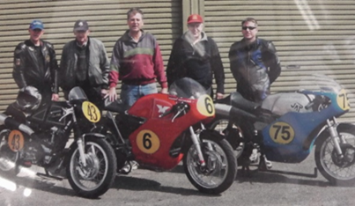
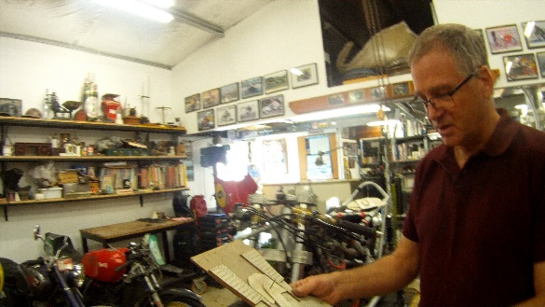
According to Greg, developing a G80 engine into a race engine begins when the flywheels started to fail. The story goes that many a G80 has had the flywheels cross the finish line ahead of the bike. It was around this time that Dave Basham really came aboard with advice and assistance. Making new flywheels? Make them lighter, from better material, larger mainshaft and smaller diameter. Due to costs, Greg couldn’t make multiple flywheels trying to find just one so, he made one flywheel fitted with a slide that he set onto a special jig. It’s not something that can be adequately described in a few words but, he could now establish the balance factors involved. Once the balance factors are known, he could then make the actual flywheels with confidence.

Next, the crankcases started to crack. First up, Greg machined out the crank centre to fit a large boss and had the now enlarged crankshaft turn on needle roller bearings. Each modification needs to be assessed in terms of its effect on other components. In this case, the oil pump had to be relocated externally which meant firstly finding a suitable pump and working how to fit and drive it. The external oil pump, from an A7 BSA, is fitted below the crank on the right side, driven off the inlet camshaft.
Greg with one of the cardboard engine mock ups.

Greg managed to get a few years of reliable racing, during which he made his own internals for a Basham carburettor, before looking for a bit more performance. Knowing that objective was beyond the original, the group went down the path of making their own patterns for a complete aluminium motor. ‘Rossco’, the pattern maker, took some convincing that the task was not to make a G80 but to make something that looked like a G80. Thousands of hours had already gone into 1:1 drawings of the motor on AutoCAD. Mostly, the drawings were the product of measuring each individual component, in 3 dimensions remember. Greg also made 2D 1:1 cardboard mock ups so he could see how the various components fitted together, or not, as alterations or further upgrades were made. Even before that, he had to research the performance and interaction of the changed materials, such as aluminium and EN36A steel, which need to live harmoniously together at racing speeds and temperatures.

First attempts to sand cast some components proved frustrating, as the molten aluminium wouldn’t flow fully properly through the mould to the extremities of the fins. The solution was found by consulting with a long retired foundry worker – push wire through the sand so the trapped air would flow through. The aluminium follows. It seems that when blokes get together in their sheds, others are often willing to provide assistance or guidance, to a point. Dave Basham, who has designed, manufactured and raced various engines, including ESO, JAP, Matchless and Enfield, was the only one who happily shared the depth of his knowledge and experience whilst Greg went through the process. It’s no wonder he holds Dave in such high regard.

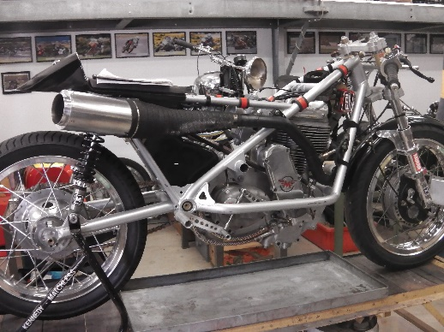
The bike races in the ‘Period 3’ class, for bikes from 1946 to 1962. Also known as the ‘Classic’ class, it is arguably the international glamour category of historic racing, due to the history of Grands Prix racing. The 500cc class is rightfully the blue ribbon category, even within Period 3. Given the age, value and rarity of original equipment, Historic Racing bike have become silhouettes of the originals, where the bikes must look like the original bikes, even if there are really no original design, materials or parts used.

When one decides to build their own bike, one may as well do as much as possible, yes? According to Greg, the original bike was about 95% his own manufacture. The current version, to his disappointment, is guesstimated at 85%. The exclusions are the 6 speed TTI gearbox, from New Zealand, the wheel rims, CDI ignition and sensors plus the Maxton suspension. It does include casting, machining and fitting of both wheel hubs and brakes. The front hub, with a double sided twin leading shoe drum brake, has 14 separate needle roller bearings installed to make certain it all works properly. Have a look at the drum brakes from any series production manufacturer you care to name and you may struggle to find any roller bearings at all.

Searching for horsepower commences with increasing compression. Over a series of different combustion heads and at least four stages of piston crown development, Greg has managed to raise the compression to roughly 14:1, with some variation depending upon internal modifications that he may make during testing. Pistons are manufactured locally, to Greg’s design. The length of the barrel has been reduced by about 37mm, permitting a redesign of the head to decrease the included angle of the valves, and the inlet & exhaust tracts. In the process, Greg re-designed the overhead valve operation, resulting in the lifters conveniently pivoting about 37mm higher above the head. Externally, the motor looks much like any cooking G80 from AMC however, on a standard head the carburettor sits horizontally. The downdraft angle on this one is a giveaway that something is going on inside the head. Shortening the barrel stiffens the entire motor, reduces reciprocating mass and permits higher revs, now out to 8500rpm. The current motor is a genuine 498cc. It can be taken out as far as 525cc, as the rules allow a 5% tolerance. Using an oversize motor is not within Greg’s planning.

A rule change allows for larger carburettors. The 1½” Amal GP carb, with their remote bowl have now been superseded by a single 40mm Mikuni VM. The carburettor change meant yet another head was needed so it was back to the casting and machining. Methanol is used, instead of petrol, the slower burn rate increasing power significantly whilst reducing combustion temperature. Perhaps that’s because of the volume of fuel streaming through them? Main jets are between #900 and #1200. Almost big enough to use as a wedding ring. A special tool is used to check each jet, irrespective of any stamping. Once checked, the jets are further marked, preventing jetting errors. Going even further, another special tool measures the slide cut away, of course permitting accurate fine adjustment of yet another critical part of the jigsaw. Tools and technicalities that we ordinary riders know nothing of.

Greg has been sacrificing original camshafts, for the drive gear. New cams are drawn and the profile is measured at 5° intervals. The drawing is transferred to a nylon or aluminium blank for proving. A second transfer into the final EN36A steel is commenced with a hacksaw, followed by a rough grind and milling at the 5° intervals, hand linished and sent for surface hardening. The cam is fitted to the modified drive gear which then allows for the cam timing to be dialled in. The oem cam drive is a concern and Greg plans to produce new gears, amongst all the other little jobs on his list.

Through all of this, Greg has meticulously maintained records, everything tabulated and cross referenced, warts and all. When the engine first ran on 2nd August 1999, his records show that the bike didn’t run all that well. In his excitement and impatience, he’d left some swarf on the needle seat of the carburettor, “I was that keen to get it going”. These days, the records include data from the rider’s seat correlated to circuit maps as well as the factual records of lap times, alterations to specification, weather conditions and so many other variables that others may not immediately consider. When proving the motor, Greg carried out 30 dry assembly / dis-assembly cycles so he could measure clearances between components before it was fired up. All recorded.

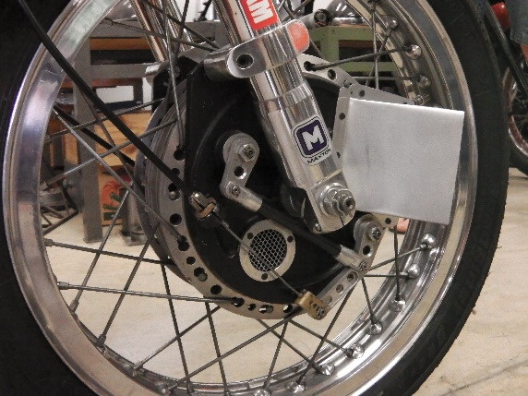
In the immediate future, Greg is looking to put the bike on a dyno. The ignition is a programmable MSD item, and the dyno will permit a comparison of the seat of the pants assessment against what is really happening at the back wheel. There are gains to be made by tweaking the ignition curve so that the motor produces its best power throughout the rev range, without dips and troughs. The MSD CDI is an expensive replacement of the earlier car based ignition, made from $25 Mitsubishi components, that was entirely satisfactory for ‘Greg the Club Racer’. When they started chasing wins, it just didn’t cut it.

A second objective for the dyno is to produce a tuned length exhaust, re-routed under the seat. Racing motorcycles fall over sometimes and Greg is getting tired of turning up new mufflers, no matter how horn they look hanging out wide on the right side of the rider’s thigh. Greg does admit that the damaged mufflers are almost exclusively trophies of his riding, the important word there being ‘almost’. Oh, let’s not forget the performance benefit from a tuned exhaust. Like the performance benefit from making his own fasteners from Duralium or Titanium rather than over the counter stainless steel. Fractions add up.

So what about this rider that I’ve been hinting at? Parents all secretly want their kids to pair up with someone that they, the parents, can get along with. How would you be if your daughter brought home some bloke that rode bikes, when bikes are in your own blood? If he was a racer? Probably better again. This is where this story goes from fantastic to incredible. Young Miss Amie Kennedy, brought Brendan Roberts home to meet Mum & Dad. Their meeting had nothing to do with motorcycles. They are now married, with two fantastic young kids. In between times, Brendan went to Europe to race some bikes. As part of the Xerox Ducati Junior team, he won the 2008 World Superstock FIM Championship. You just can’t make this stuff up!

While Greg reckons he can ride anything, irrespective of gearing, suspension or rider position, Brendan, he says, is a “bit of a princess”, working until everything is just right. After both dancing around the subject of Brendan riding the Matchless, he was the motivation for Greg and his mates to take on much of the recent work. ‘Princess’ has taken the bike to a completely different level. Brendan replaced the modified standard forks and Koni rear spring/dampeners with top notch Maxton items. A freshly cast, lighter front hub is ready to go onto a lathe. The standard seat and tank arrangement is altered so that Brendan can get his weight forward and climb off the side of the bike. The ignition, carburetion, their dyno plans are all a result of Brendan taking hold of the handlebars. Essentially, his skill lets him identify those seemingly insignificant factors that help put the result on the podium.
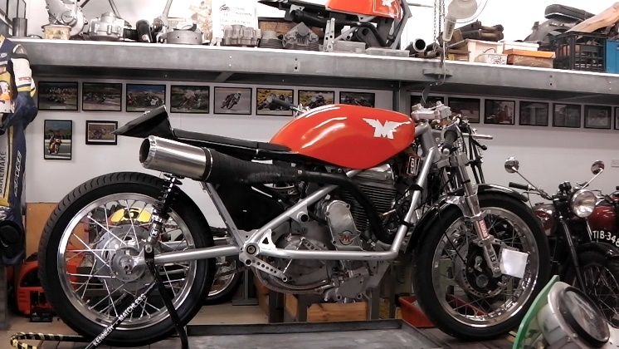
If there was a down side to Brendan’s input, Greg found it when the more forward ride position let him flip the bike under brakes, leaving him sitting on the track whilst the bike landed back on its wheels and rolled off the side of the track. Of course, no one had a camera on it at the time.

The team was unlucky not to figure in the 2015 Australian Historic Racing Championships, due to a racing collision in the final leg. Not to be daunted, they are lining up for the 2016 Island Classic in January and then they will look at what may follow. That may just be some more shed time turning another set of castings into the G50 replica they are designed to be.
The Kennedy Matchless G80, with McIntyre frame, in its current format, sans fairing.
G50 castings are on the shelf behind.

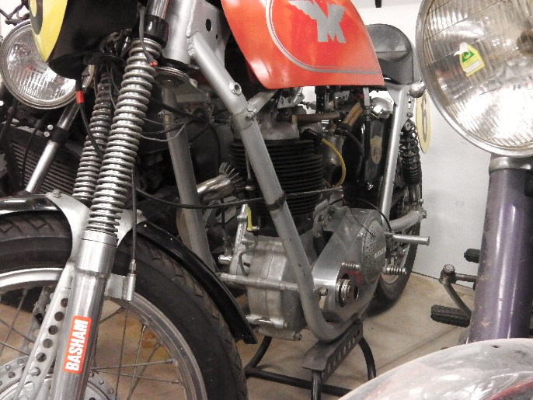
the earlier Matchless within the replica AJS 7R (oval section) frame.

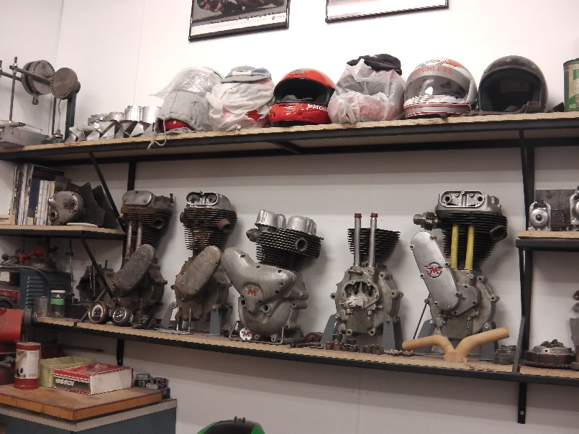
Trophies to the Gods of Speed, ala Bert Munro

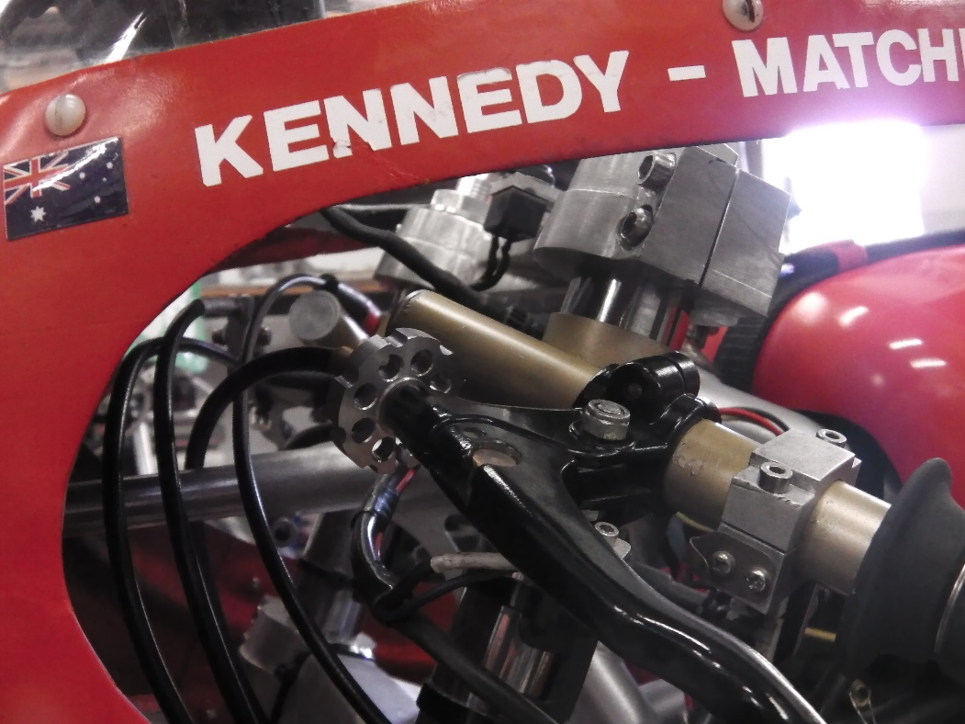
Attention to detail is also found behind the firing.

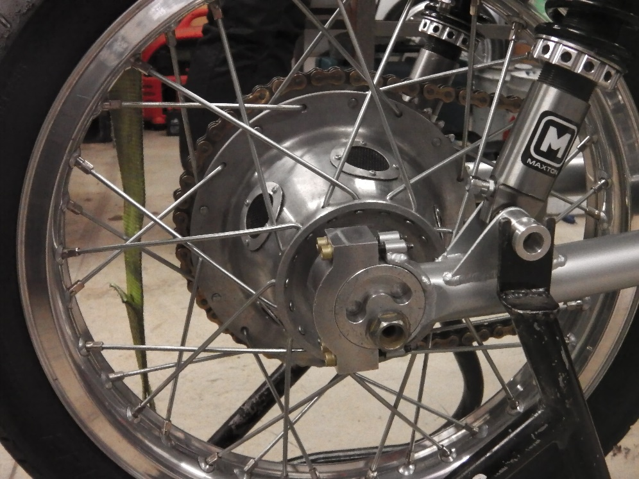
And the rear hub

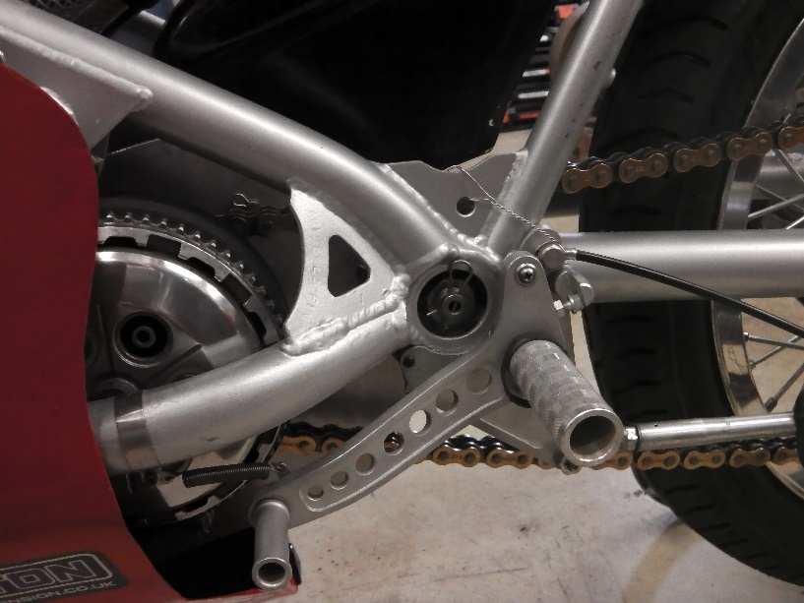

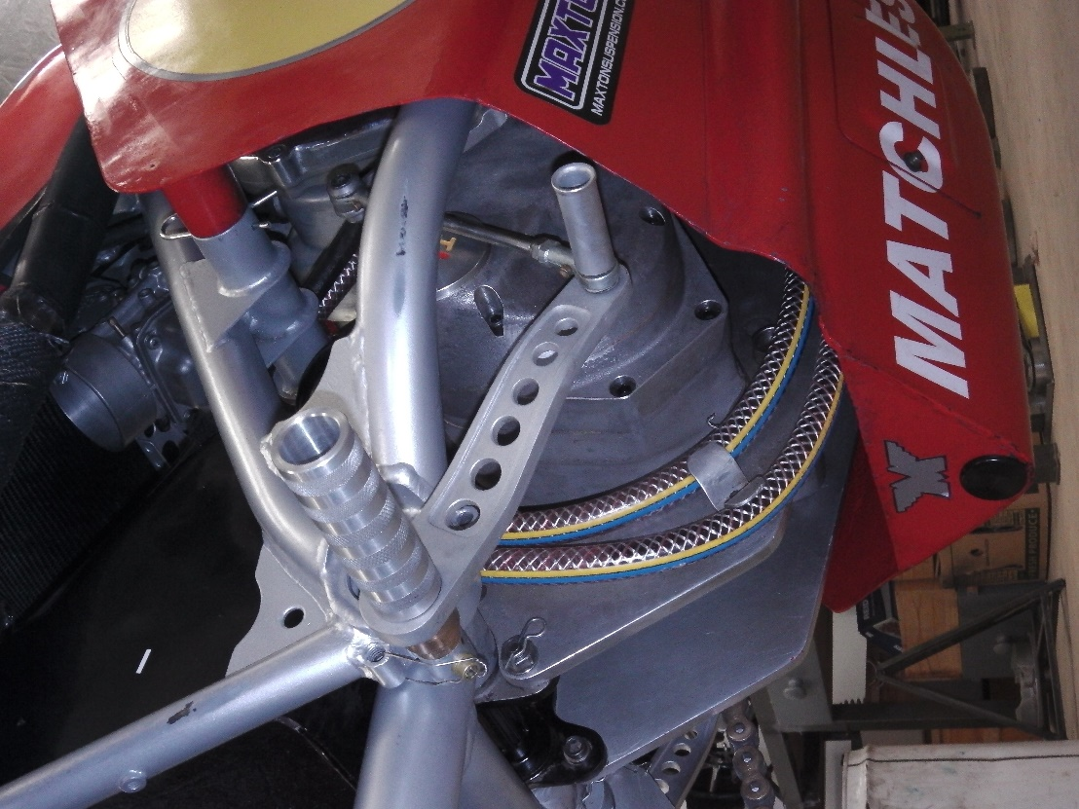

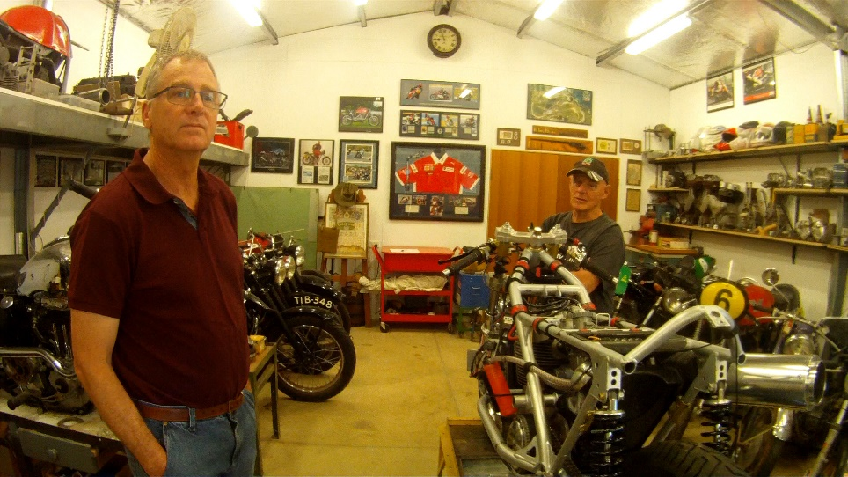
Greg (left) with John Whallan.

